Experiment 7

Aim:

Create a Virtual Machine with 1 CPU, 2GB RAM and 15GB storage disk

using a Type 2 Virtualization Software, using virtual box.

Procedure:

STEP 1: Dowload VMware workstation and installed as type 2 hypervisor.

STEP2: Dowload ubuntu or tiny OS as iso image file.

STEP 3: In VMware workstation->create new VM.

STEP 4: Do the basic configuration settings.

STEP 5: Created tiny OS virtual machine.

STEP 6: Launch the VM.

Output

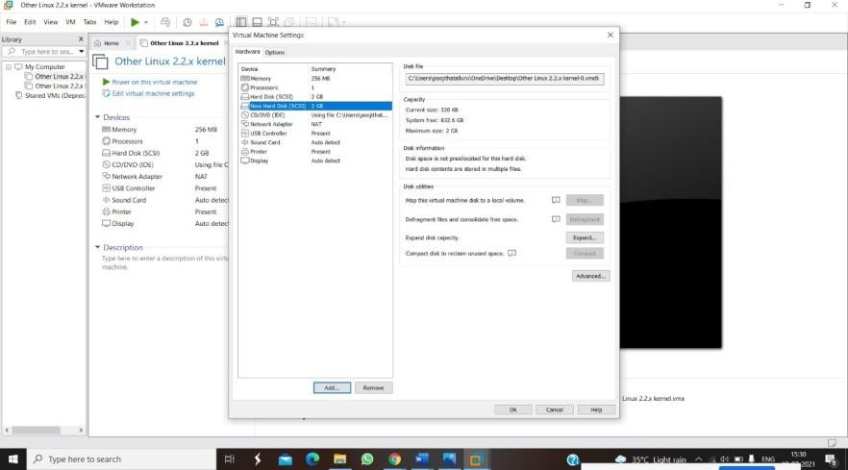

Result: The experiment was executed successfully